caTissue PSC Integration Design

V 0.0.3

10/14/2010

Authors | Carlos E. Perez
Reviewers
Architecture Inception Team

DOCUMENT CHANGE HISTORY
Version Number | Date | Contributor | Description
0.0.1 | 08/17/2010 | Carlos Perez | Initial version
0.0.2 | 08/19/2010 | Carlos Perez | Edit based on Poornima’s comments.
0.0.3 | 10/14/2010 | Carlos Perez | Edit based on Rakesh, Ram, Brent comments
0.0.4 | 12/28/2010 | Carlos Perez | Formatting Update by Jithu Ramesh

Table of Contents
1 PSC Integration Design 3
1.1 System Flow 3
1.2 Behavior 3
1.3 Components 3
1.3.1 Study Mapping 3
1.3.2 PSC Behavior and Mapping 3

PSC Integration Design
For Calendar events that have an associated biospecimen collection, PSC will broadcast notifications to caTissue. These notifications will include a call-back to the Calendar service. The call-back will synchronize caTissue CollectionProtocolEvent with PSC PlannedCalendar. The caTissue CollectionProtocolEvents that are associated with the CollectionProtol is synchronized with PSC PlannedCalendar. caTissue CollectionProtocolRegistration and SpecimenCollectionGroup are synchronized with the PSC ScheduledActivity,
There will be one notification message sent by PSC about changes in the ScheduledCalendar. The Calendar Service will provide a query that returns all ScheduledActivity objects within a specified time period. With the ScheduledActivity at the root, it is expected that the PlannedCalendar and its referenced Study are accessible.

Create Calendar for Subject
Use Case Description: After a Subject Coordinator assigns a subject to a study, he or she creates a calendar of activities by scheduling segments.
Use Case Name | Create Calendar for Subject
Use Case ID | PSC_UC_012
Primary Actor | Subject Coordinator (SubC)
Secondary Actor | None
Brief Description | SubC creates a calendar of activities by scheduling segments.
Trigger | Subject assigned to a study.
Pre-conditions | Must know when the subject will begin in the study and which segment he or she will be on in the first epoch (if applicable).
Flow of Events | - Subject assigned to study.  - The SubC selects a segment and enters a start date for that segment.  - If the next segment is known, the SubC selects the next segment and enters the start date for it as well as noting whether the change is “immediate” or “per protocol.”  - Repeat step 3 for all known segments.  - The calendar is automatically (re)generated with each segment assignment.  - The system shall broadcast a ScheduledActivity Change for the subject into the ESB.
Post Conditions | The subject has personalized schedule for his or her involvement in the study.
Branch Point - <error handling> | None
Quality Use Case | None
Related Use Cases | PSC_UC_010, PSC_UC_021
Business Rules | None

Manage Scheduled Activities for a Subject
Use Case Description: Subject Coordinator accesses a subject’s calendar and is able to record information about the scheduled activities. Specifically, the activities can be rescheduled or marked as having occurred, been missed, or been canceled. The PC may also make notes about the activities.
Use Case Name | Manage Scheduled Activities
Use Case ID | PSC_UC_021
Primary Actor | Subject Coordinator (SubC)
Secondary Actor | None
Brief Description | Manage the scheduled activities in a subject’s calendar.
Trigger | SubC accesses the calendar of a subject.
Pre-conditions | - Subject assigned to study.  - Calendar generated for subject.
Flow of Events | - The SubC accesses a subject’s calendar.  - The SubC selects a scheduled activity.  - The SubC reschedules the activity or marks it as canceled, missed, or occurred.  - The SubC makes notes about the activity.  - The system shall broadcast the ScheduledActivity for the subject into the ESB.
Post Conditions | The subject’s schedule has been updated.
Branch Point - <error handling> | None
Quality Use Case | None
Related Use Cases | PSC_UC_010, PSC_UC_012, PSC_UC_022.
Business Rules | None

System Flow
How does data flow through the system?

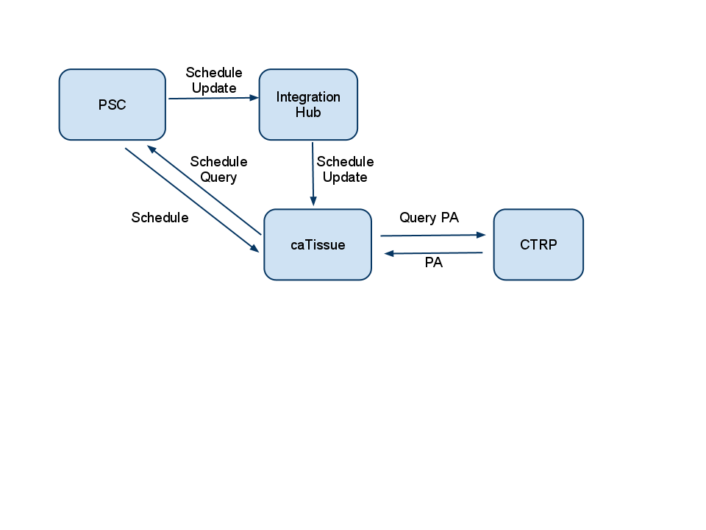
Figure 1. Diagram of System Flow

Behavior
- On reception of a ScheduledActivity Change from PSC.
- CaTissue will consume this message and use it to locate the ScheduledActivity using the Calendar Service.
- The ScheduledActivity with its associated PlannedCalendar is retrieved.
- The PlannedCalendar should have a reference to a Study so that that a CollectionProtocolRegistration can be identified. The PSC ‘assignedIdentifier’ attribute is used to locate the Study. (Note: The Study was previously created in the C3PR integration).
- A lookup for the CollectionProtocolRegistration object is done. If it is absent, a new one is created.
- SpecimenCollectionGroups are created for the using the CollecitonProtocolRegistration.

Issues
- PSC notification needs to be implemented.
- Activity Types and their code may need to be aligned to a codesystem. caTissue can specify activities that it understands.(Nice to have) At a high level event, alignment may be valuable.
- Activity properties allow arbitrary key value pairs with an activity. This is an alternate way to identify caTissue relevant activities.
- CSM Security Role Model may require alignment. If the Study already exists, it is likely that the system will perform the updates without requiring a User’s role.

Components

Study Mapping
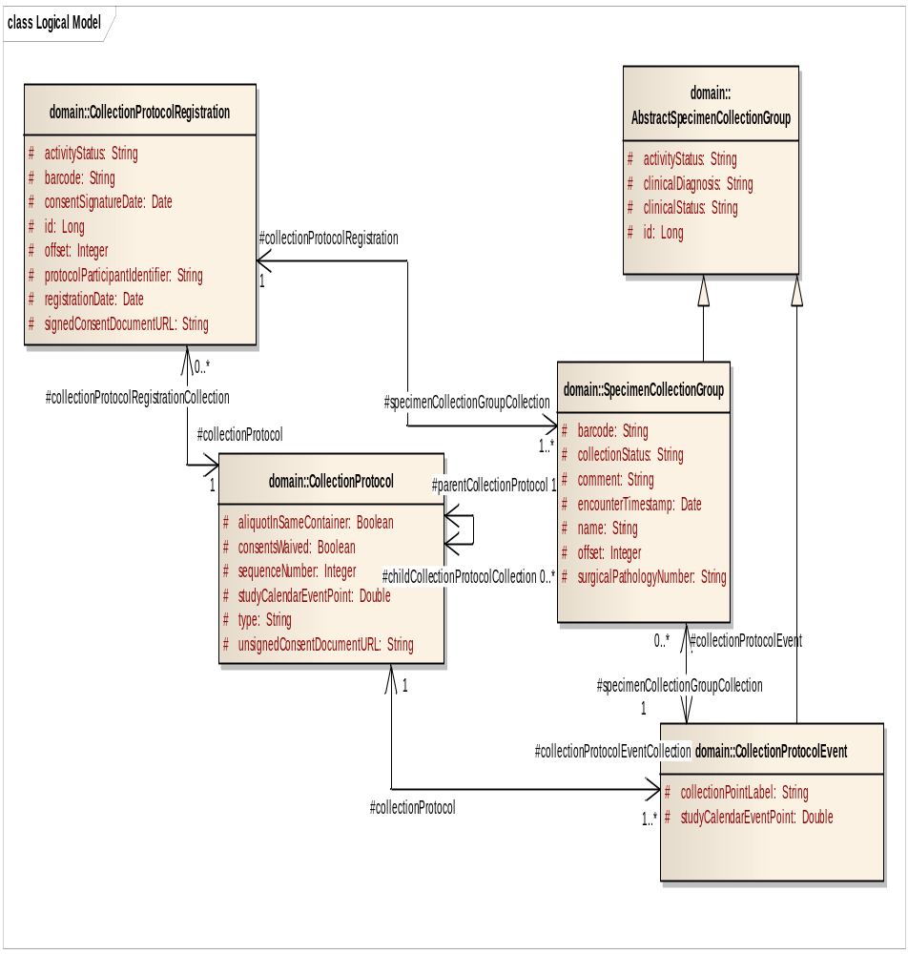
Figure 2 Diagram of PSC

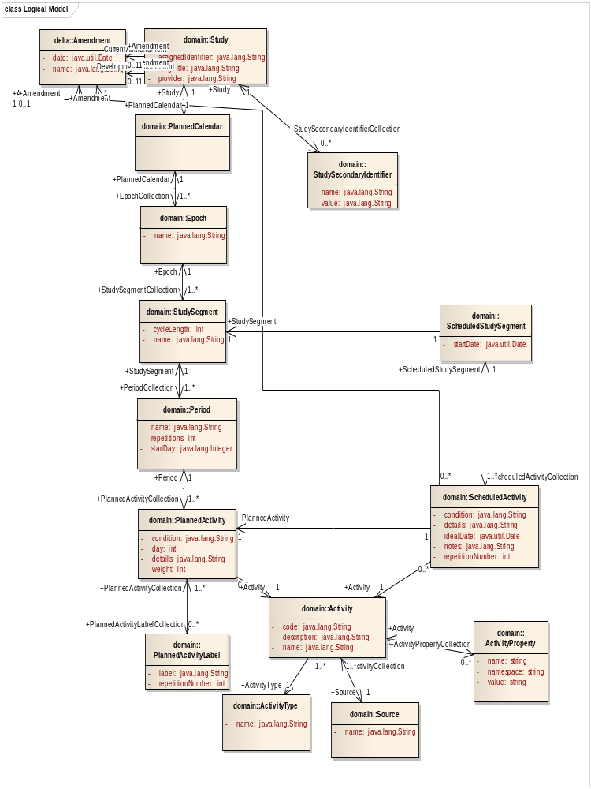
Figure 3. Diagram of PSC

PSC Behavior and Mapping
On creation of a PlannedCalendar, the epoch structure is transformed into CollectionEvents that are associated with the CollectionProtocol that was previously created when the system received a C3PR Study. The correlation id the irbIdentifier attribute of the CollectionProtocol.
PSC | caTissue
PlannedCalendar | CollectionProtocolEvent
When a ScheduledActivity is created by PSC it is sent to caTissue with the associated PlannedCalendar. The PlannedCalendar should point to the associated Study so that caTissue can resolve the associated Study and therefore the CollectionProtocolRegistration. A sequence of SpecimenCollectionGroups are created and associated to the CollectionProtocolRegistration.
In the event that the ScheduledActivity does not have its date aligned with the PlannedActivity, then caTissue will need to calculate Offset is change in schedule relative to planned activity.
PSC | caTissue
ScheduledActivity.condition | N/A
ScheduledActivity.details | SpecimenCollectionGroup name
ScheduledActivity.idealDate | SpecimenCollectionGroup.encounterTimeStamp
ScheduledActivity.notes | SpecimenCollectionGroup.comment
ScheduledActivity.repetitionNumber
 | SpecimenCollectionGroup.collectionStatus=Pending
ScheduledActivity.activity
Activity.code
Actitivity.description
Activity.name
Activity.activityType | Use only those classified as collection
Issue: How does one identify the Study that is associated with the Participant in PSC? Is the Study 1:1 with Participant? Is Planned Activity one: many with the Study?

